SF.SmokeTestScripts_TC_SF_ManagerLogin_Instance1_18-Apr-2017_12-56-15_AM_Invoke_Application.png



SF.SmokeTestScripts_TC_SF_ManagerLogin_Instance1_18-Apr-2017_12-56-29_AM_Invoke_Application.png

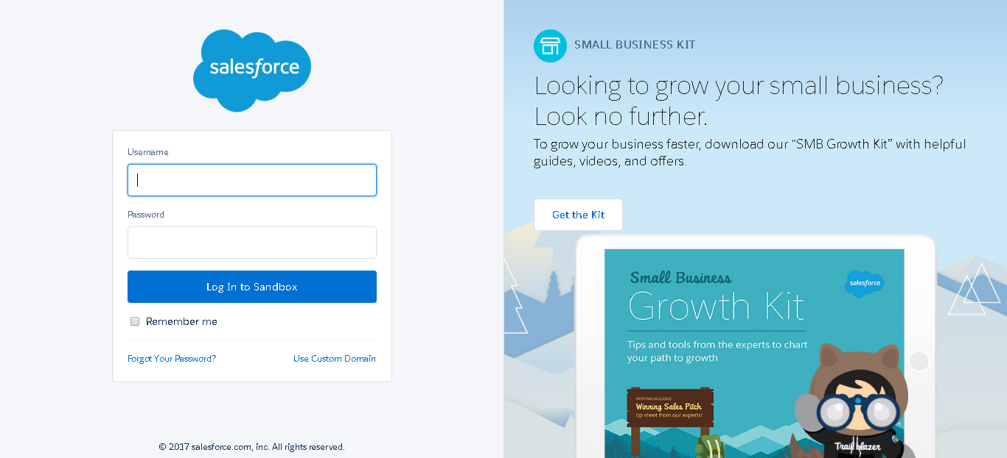

SF.SmokeTestScripts_TC_SF_ManagerLogin_Instance1_18-Apr-2017_12-56-39_AM_Login.png

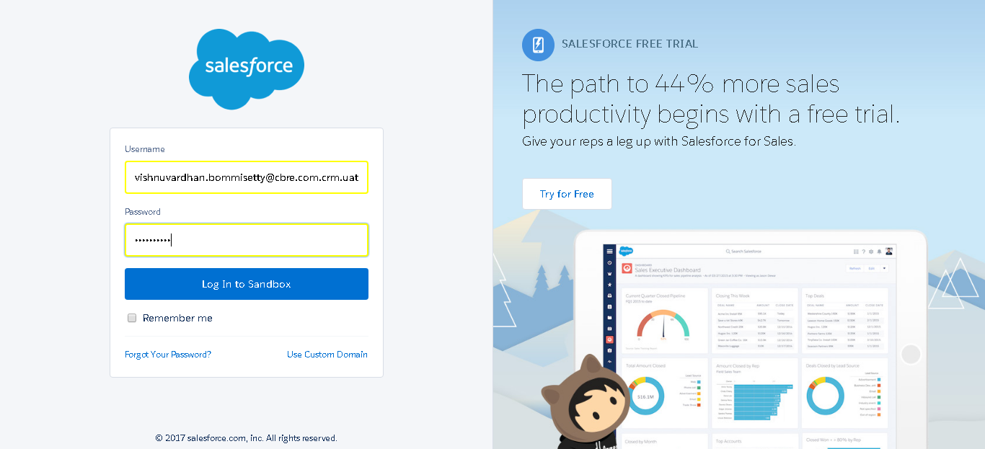

SF.SmokeTestScripts_TC_SF_ManagerLogin_Instance1_18-Apr-2017_12-56-56_AM_Verify_Login.png

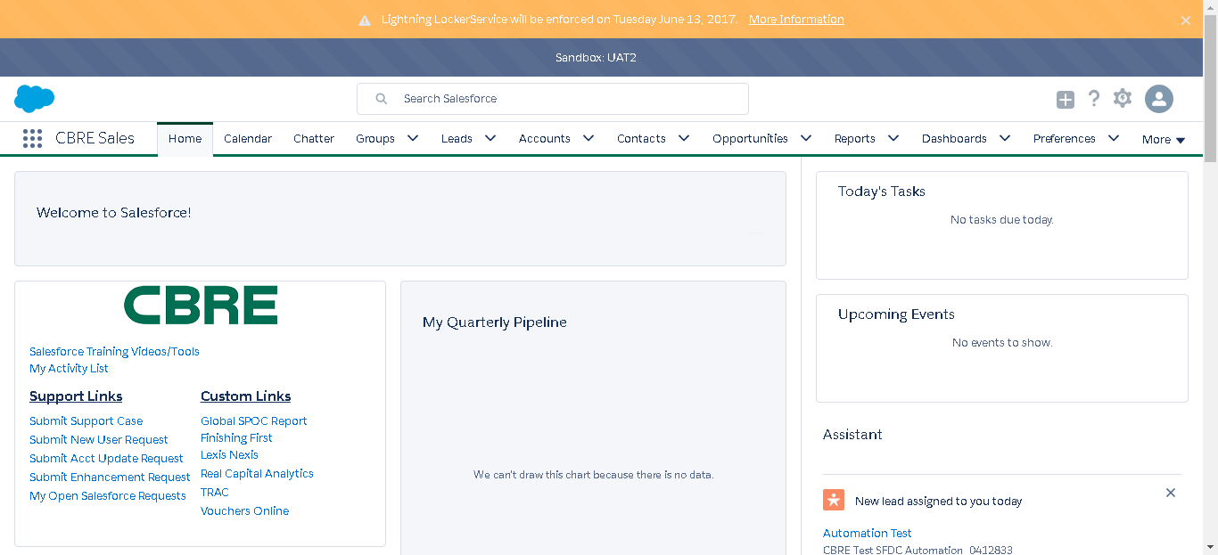

SF.SmokeTestScripts_TC_SF_ManagerLogin_Instance1_18-Apr-2017_12-57-10_AM_Verify_Logout.png

